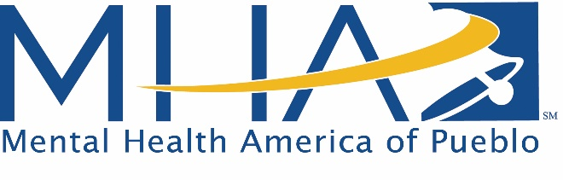

The mission of Mental Health America of Pueblo is to strive to eliminate the stigma of mental illness and to increase access to treatment through education, advocacy, and research development.

Request for Nomination– Phoenix Award
Awarded during the month of May at our annual Robert Hawkins Tribute Dinner. Specific date TBA

Nomination Deadline: Friday, January 31, 2020.
Please complete this form using Word, save, and email to: mhapueblo@gmail.com
You may also send by mail to MHA-Pueblo, P.O. Box 1423, Pueblo, 81003.

Criteria
Nominations must be for an individual living with a mental illness that has demonstrated significant achievements or advancements in the mental health community that compliments the MHAP mission.
Nominee Information
Name of Nominee: Click or tap here to enter text.
Preferred Phone: Click or tap here to enter text. Email: Click or tap here to enter text.
Place of Employment (Optional): Click or tap here to enter text.
Address: Click or tap here to enter text.

Nominator’s Information
Your Name: Click or tap here to enter text.
Preferred Phone: Click or tap here to enter text. Email: Click or tap here to enter text.
Place of Employment (Optional): Click or tap here to enter text.
Address (Optional): Click or tap here to enter text.

Nomination Justification:
- Describe the specifics of the nominee's achievements that reduce the stigma of mental illness and/or impact (either directly or indirectly) individuals, families, groups or the Pueblo community.
- What attributes uniquely characterize the nominee and why is this person deserving of recognition as it relates to the MHAP mission statement above?
- How has this individual demonstrated excellence in areas like commitment to mental health or progressive actions in the areas of mental health, advocacy, leadership or collaboration?
- Additional information or comments.

Describe the nominee’s accomplishments using the questions above: Click or tap here to enter text.

